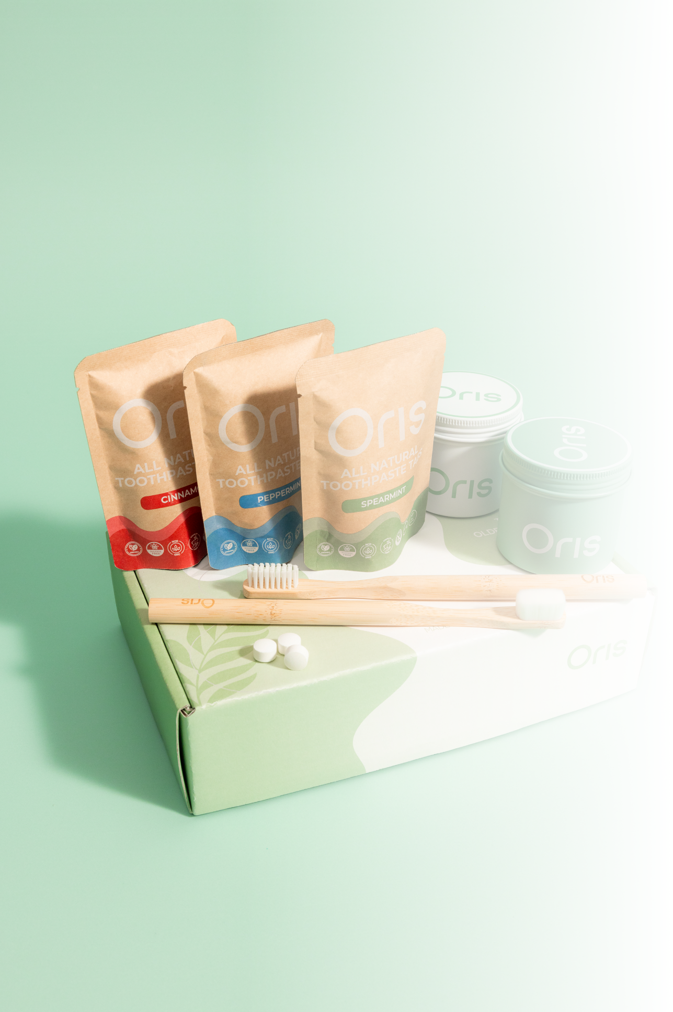

CASE STUDY
How a Sustainable Oral Care Brand Turned Email into a Relatable Growth Engine

Industry | Sustainable Oral Care
Platform | Klaviyo
Services | Email Flow Design, Campaign Strategy, Creative Design, Performance Analytics.

- The Challenge
A forward-thinking brand specializing in eco-friendly toothpaste tablets, had built a commendable product line and a loyal customer base. However, they had not yet ventured into email marketing, a channel they acknowledged held significant potential for growth and customer retention

- The Starting Point
When this client first booked a Calendly call with us, they had a great product, loyal customers, and sloid brand values but one thing was missing: Email Marketing

They had never run a campaign. No flow. No list segmentation. But they knew email has potential.
In that very first call, we walked them through how email could:

- Drive consistent, trackable revenue
- Build stronger customer relationships
- Reduce reliance on ads
- Turn their store into a sustainable growth engine
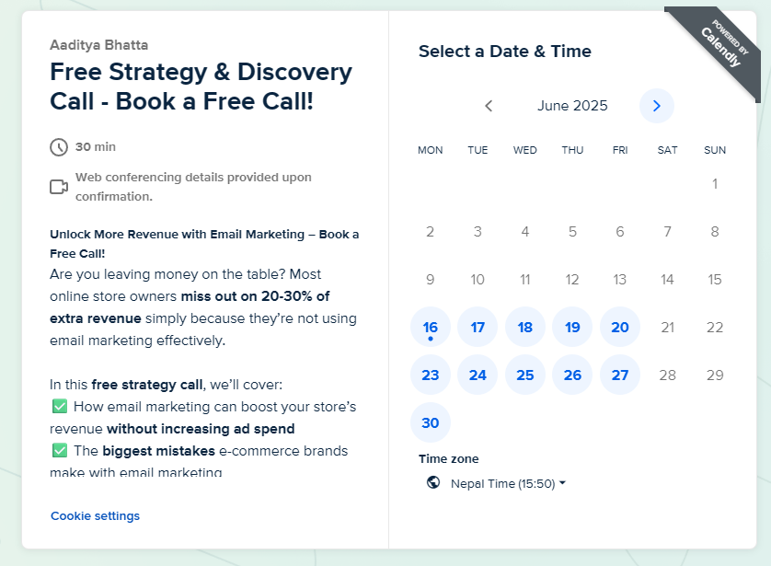


By the end of the call, they were fully on board and within days, we began building the foundation

- Our Approach
- Launched High-Converting Email Flows
We started by setting up a complete automation system designed to capture revenue and create value without constant manual input:
- Welcome Series – To introduce the brand and convert subscribers into first-time buyers
- Abandoned Cart - To recover missed sales
- Post- Purchase – To build loyalty and drive repeat orders
- Browse Abandonment - To re-engage product viewers
- Winback – to revive lapsed customers
Each flow was fully branded, designed for performance, and structured to reflect the brand’s tone and mission.
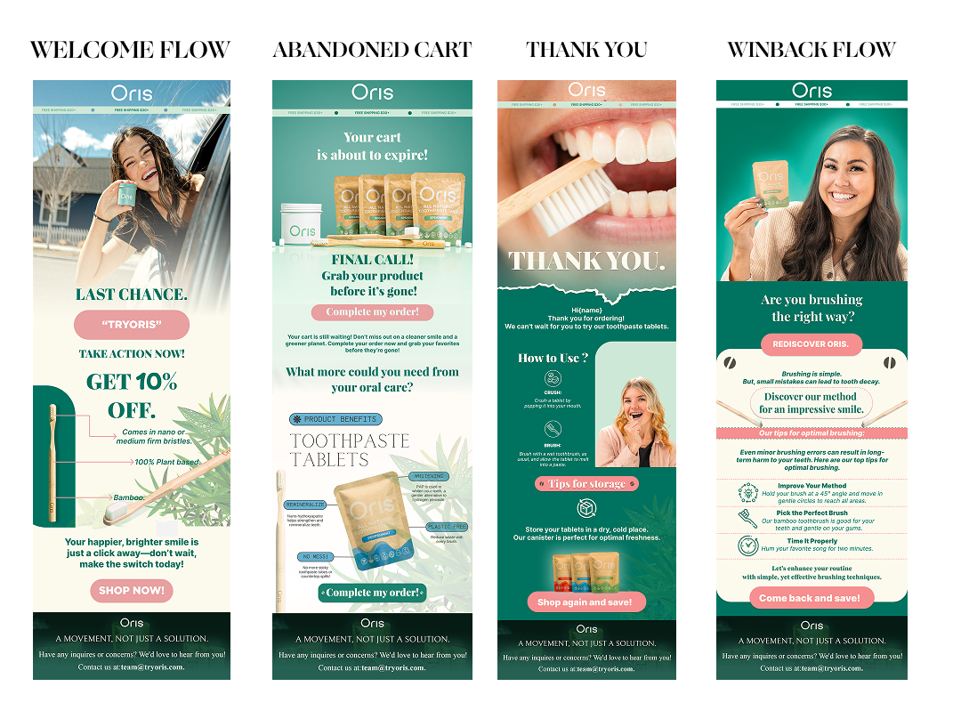
- Built a Campaign Engine
Automation alone isn’t enough. So we developed a monthly campaign calendar that aligned with key sales moments, seasonal trends, and storytelling opportunities.
- Clear goals and CTA for every campaign
- Themes tied to customer behavior, holidays and product drops
- Consistent send schedule with on-brand visuals and engaging copy
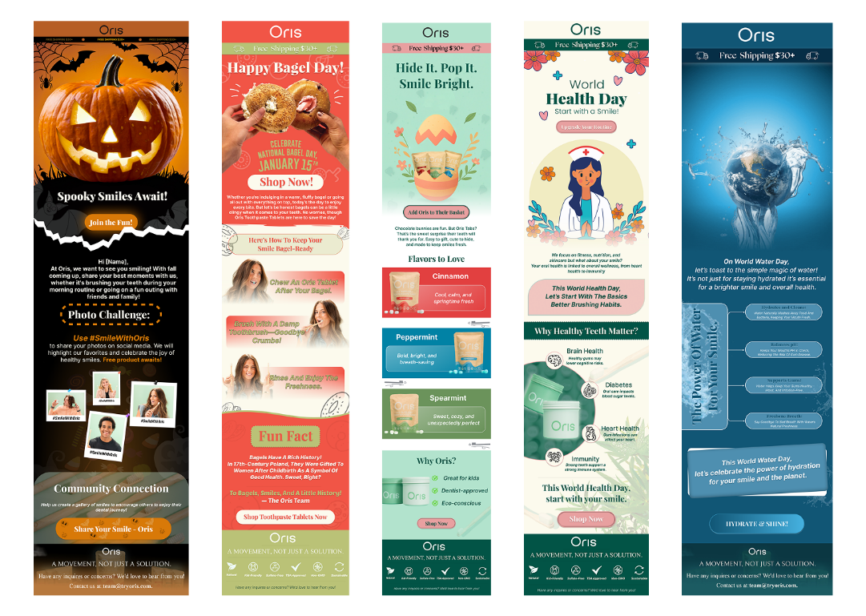
- Monitored, Tested, Optimized
Every email was tracked in real-time. We continuously tested:
- Subject Lines
- Content formats
- Timing & segmentation
- Promotional Strategies
The result? Continuous improvement and clear, measurable growth.
- The Result (First 60 Days)

Email Revenue: $6,428.51
Open Rates: Avg 48%
Flows vs. Campaigns: Automated flows drove 62% of email revenue
Top Campaign: Black Friday Sale over $1000 in one email

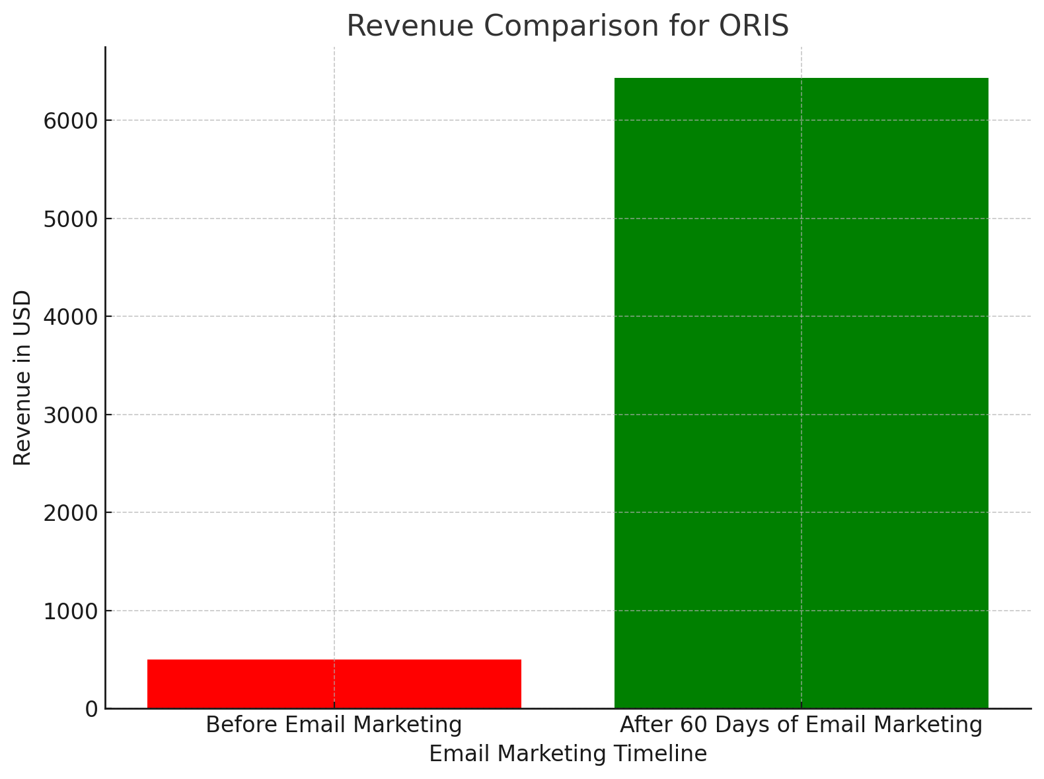

- Performance Overview
The numbers that turned a silent inbox into a high-performing revenue stream
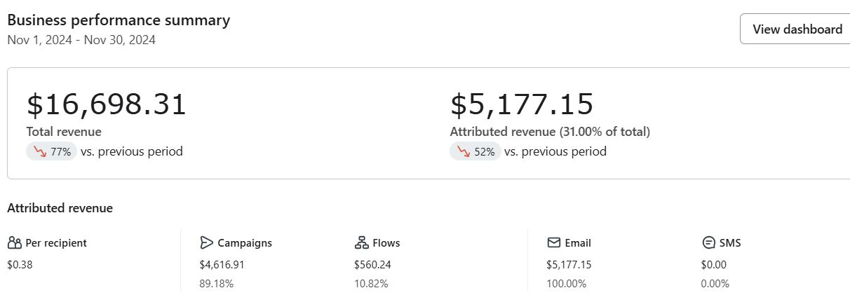
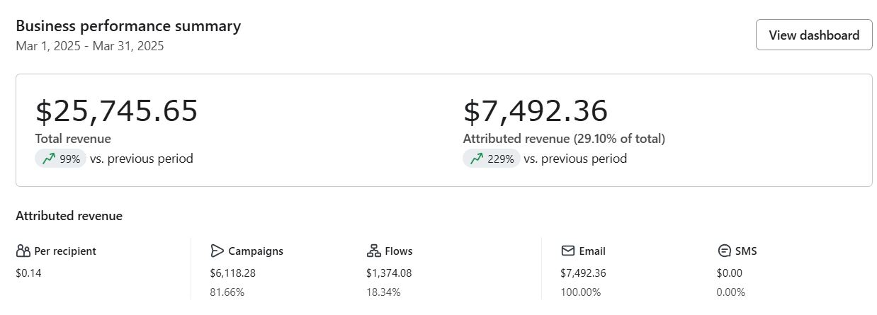

- A Few Smart Campaign Highlights

DATE | Campaign Name | Theme/ Focus | Revenue
Oct 30 | Unwrap the Magic of Cinamon | Fall product launch | $115.95
Nov 4 | Keep Your Smile Bright | Holiday Health Tips | $513.61
Nov 18 | Black Friday Starts Early | 30% off early access | $1,036.85
Nov 25 | Post-Feast Reset | Thanksgiving health reminder | $764.81

Campaigns were more than just promos, they were little moments to connect with customers.
- What Made It Work
- Speed to Execution: From strategy to live emails in weeks
- Brand-First Design: Every flow and campaign reflected the brand’s clean, modern aesthetic.
- Clear, Helpful Content: No fluff. Just valuable, human-first messaging
- Consistency: A steady presence in the inbox without over-sending
- What Happened Next
With a solid foundation in place, we continued to:
- Run targeted monthly campaigns
- Adjust flows based on real customer behavior
- Introduce new ideas like review collection, product education, and subscriber engagement sequences
The email channel is now a key driver of both revenue and retention and continues to grow each month.

- From The Client
“We always knew email was important but Outreach Gurkha helped us turn it into one of our best-performing channels. The process was seamless, the emails were beautifully done, and the results spoke for themselves”

- Final Takeaway
In just 60 days, we helped transform a silent inbox into a consistent, revenue-generating asset
Backed by smart automation, thoughtful campaign and real data.

And to think It all started with a 20-minute call.

